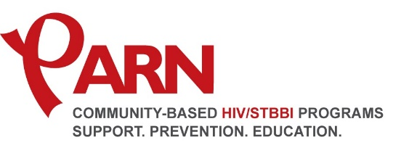
Peterborough AIDS Resource Network Board of Directors Application Information
PARN is a non-profit, community-based organization which is dedicated to providing support and health promotion to those in our communities who have lives that have been touched by HIV/AIDS/HCV. We proudly serve the people of the four counties of Peterborough, Northumberland, Haliburton and Kawartha Lakes. PARN’s operations are overseen by a volunteer-driven Board of Directors who, on behalf of the people of Peterborough and the four counties, ensure the accountability of PARN.
Board Member Responsibility Overview
The purpose of the Board of Directors is to provide leadership and direction for the agency and to ensure accountability to the community. The mandate of the Board of Directors is to govern the organization by developing and overseeing the implementation of policy. To serve on the board, an individual must acknowledge that they agree with and support PARN’s mission statement, philosophy and goals. Other duties and responsibilities include:
- To attend monthly meetings of the Board, applicable committee meetings and other meetings as shall be considered necessary
- Be prepared to participate in the discussions and deliberations for the Board and applicable committees
- To participate in the selection, performance appraisal and termination, if necessary, of the Executive Director
- To support fundraising activities of the agency
- To know and adhere to the policies of PARN concerning conflict of interest and confidentiality
Composition
The Board of Directors will be comprised of 9 members plus the Executive Director. The Board membership will include Chair of the Board, Vice Chair of the Board, Treasurer / Secretary & 6 members at Large.
Serving on the Board of Directors for PARN requires:
- A commitment to providing services to people infected and affected by HIV/AIDS in the four counties and a strong commitment to supporting the lives and human rights of people HIV infected
- A general knowledge of, interest in, or experience with health, social services, social justice, advocacy, community development or HIV/AIDS
- Willingness to assume a leadership role in the ongoing maintenance and development of PARN
- A commitment to act in the best interest of PARN and not as a spokesperson for any special interest group, themself or any particular geographic region.
Term Of Office
Directors must be members in good standing of the organization and shall be elected or appointed according to the by-laws of the organization. The term of office for the Board members shall not exceed two (2) years. A Board member is eligible for re-election for two (2) consecutive terms not exceeding five (5) years in total. After an absence of twelve (12) months from the Board a member is eligible to stand for election.

